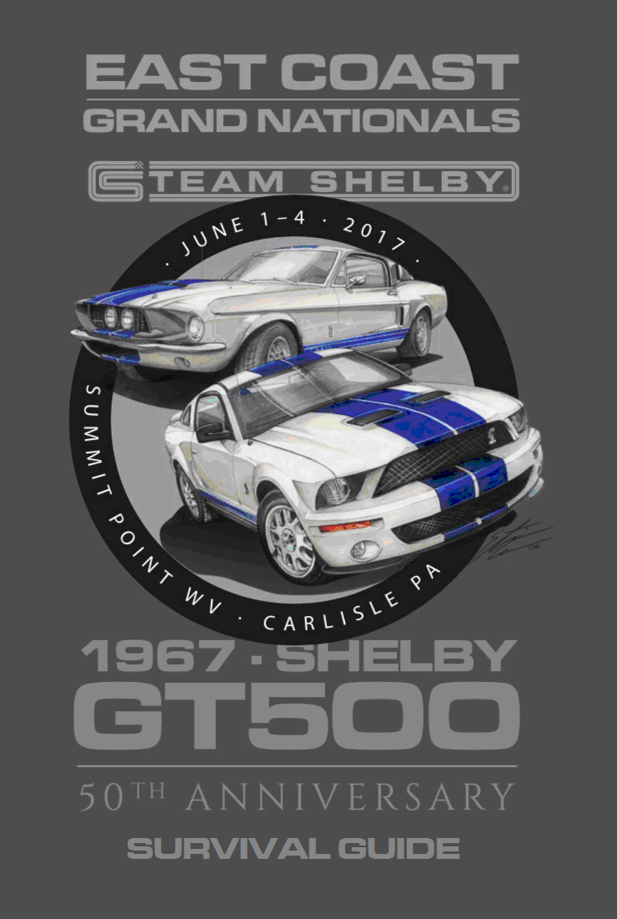

2017 Team Shelby East Coast Grand Nationals Hosted by Northeast and South Atlantic Regions
Welcome to the 2017 Team Shelby East Coast Grand Nationals. We would like to thank you for helping us celebrate this event. Team Shelby moves the Grand National event from region to region each year and this year it is back in the North East. Be safe and have a great time!

This Survival Guide will provide you with all the critical information you’ll need to be successfully involved in ALL the planned events. If you have any questions, please flag down one of the Team Shelby Organizers or STAFF members and they will provide you with the information that you need. (Some minor changes may have occurred after the printing of this document)

The year’s Survival Guide is arranged in the sequence of events to better prepare you with information you will need for each event.

Registrations and Credentials – When you purchased a package for the 2017 Team Shelby East Coast Grand Nationals event you were sent an email from PayPal. This PayPal receipt serves as your confirmation. When you arrive at either Summit Point or Carlisle, you will check in and receive your credential packet in person. Please remember to have photo ID when checking in. This packet will contain everything you need to access all Team Shelby Events.

Wear your badge at ALL times. It’s key to remember this for the entire event.

There are 4 packages to choose from:

- The Summit Point Package: Hooked On Driving Wrist Band; includes the track driving event and lunch at the track. If you’re not tracking your car, you can enter your Ford Performance vehicle into a car show (purchased separately) which gets you into the track paddock area as a spectator too!
- The Charles Town Package includes: White Badge; door decals, an after track party, featuring a buffet dinner at the casino with Special Guest appearances and a Team Shelby sponsored horse race.
- The Carlisle Package includes: Blue Badge; door decals, a Poker Cruise from Charles Town, WV to Carlisle, PA, the Team Shelby Grand Entrance into Carlisle, Cars under the Stars (w/dinner), Show & Shine Car show, a Red Carpet event for a special movie premier.
- The Grand Package includes: Gold Badge; all the features in both Charles Town & Carlisle Packages (but only one set of door decals)

TABLE OF CONTENTS
Event Schedule Summary 4
Hotel Information for Track Event 4
Summit Point Motorsports Park Track Event 5
After Track Event Party/Dinner 9
Poker Cruise from Charles Town, WV to Carlisle, PA 10
Team Shelby Grand Entrance 18
Hotel Information for Carlisle, PA 19
Cars under the Stars 20
Team Shelby at Carlisle All Ford Nationals 21
Carlisle Saturday Night Parade and Team Shelby Special Event 22
Carlisle Awards & Wrap-up 23
Detailed Schedule of Events 24
Hollywood Casino to Summit Point Motorsports Park Map 26
Hosts, Affiliates & Sponsors 27

QUICK LINKS

2017 Carlisle Ford Nationals Showfield registration:
http://store.carlisleevents.com/SearchResults.asp?Cat=24
Choose the TEAM SHELBY drop down under clubs when registering!

The Inn at Charles Town – Charles Town, WV
http://www.hollywoodcasinocharlestown.com/hotel

Comfort Inn PA Turnpike – I-81 in Carlisle, PA
https://www.choicehotels.com/…/car…/comfort-inn-hotels/pa693

EVENT SCHEDULE SUMMARY
*ABBREVIATED SCHEDULE
Date: | Time: | Place: | Event
Thurs June 1st | 7:00 am – 5:00 pm | Summit Point, WV | Track Time
 | 5:30 pm –11:30 pm | Charles Town, WV | Dinner/Social/Horse Race
Fri June 2nd | 8:00 am – 2:00 pm | Charles Town, WV | Poker Cruise
 | 3:00 pm – 5:30 pm | Carlisle, PA | Shelby Grand Entrance/Tent
 | 5:30 pm – 10:30 pm | Ford Expo Center Carlisle, PA | Cars under the Stars/Dinner
Sat June 3rd | 7:00 am – 5:00 pm | Carlisle, PA | Team Shelby Tent @ Carlisle
 | 6:00 pm – 10:00 pm | Carlisle, PA | Parade/Social and a Movie
Sun June 4th | 7:00 am – ? | Carlisle, PA | Team Shelby Tent @ Carlisle

*CREDENTIALS PICKUP
Date: | Time: | Place: | Location
Wed May 31st | 6:30 pm – 10:00 pm | Charles Town, WV | Hollywood Casino, WV
Thurs June 1st | 7:00 am – 5:00 pm | Summit Point, WV | Team Shelby Station
Fri June 2nd | 5:30 pm – 7:30 pm | Carlisle, PA | Ford Expo Center Lobby
Sat June 3rd | 7:00 am – 5:00 pm | Carlisle, PA | Team Shelby Hospitality Tent
* Don’t forget to bring your photo ID and PayPal receipt.

Hotel Information for Track Event

May 31st – June 2nd
If you are attending the track portion at Summit Point Motorsports Park, you’ll need a place to stay. We found a very nice option for you.

West Virginia:

Charles Town, WV – The Inn at Charles Town.
If you haven’t booked your hotels yet, do so ASAP space is getting very limited.

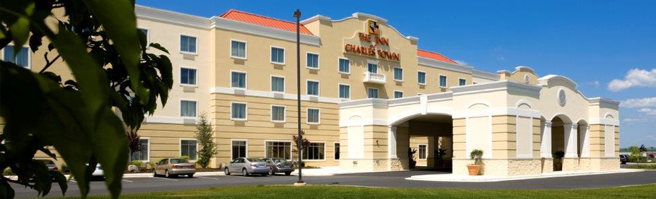
We have 35 rooms blocked for Team Shelby. If they go fast we can get more. 18 King rooms, 17 deluxe 2 queen beds. Use group code is TEM0531.

100 Hollywood Drive, Charles Town, WV 25414
http://www.hollywoodcasinocharlestown.com/hotel
For reservations call: 1-800-795-7001.
$99.00* per night, plus 12% tax
Check in – May 31st, Checkout – June 2nd

* To receive the $99.00 room rate you must mention “The Team Shelby group code TEM0531” when making your reservation. NOTE: The room rates blocked off for Team Shelby will return to normal inventory prices if not fully booked by May 21, 2017.

The hotel provides a complimentary breakfast buffet daily from 6:30pm – 10:00 pm on the 1st floor of the hotel.

There is shuttle service to the horse track and casino. There's a fitness center, as well as several dining options at the casino, which also features slots, table games and entertainment.

Summit Point Motorsports Park Event

Summit Point Circuit – Thursday June 1st
Please read the enclosed Track Information and Mandatory Safety Items BEFORE arriving at Summit Point Motorsports Park.

Consumption of alcoholic beverages is NOT permittted at Summit Point Motorsports Park

All drivers must attend the drivers meeting and classroom instruction in the morning at 8:00 am (Track opens @ 7:00 am). Instructors will be on each run with the driver to assure you are driving your car to the best of your ability. This event is not a race but the opportunity to learn/practice your driving skills at high rates of speed… safely!
ANYONE registering to track, MUST choose an appropriate run group:
Beginner - This is the right choice for someone with no, or very little track experience. This group will attend a 45 minute classroom session at the beginning of the track day. This is a controlled pace group that runs under strict rules on-course. Drivers in this group MUST attend the classroom session before going on the track. Late arriving Beginner drivers may forfeit their ability to attend this track day. Coaches will be on hand to support this group, provide lead-follows on track or ride as passengers in student vehicles as needed.
Intermediate - This group is for drivers that have been previously approved as a solo driver and have completed several track days as a solo driver. Passing is restricted to the straights only and point-bys are mandatory.
Advanced - This group is only for drivers that have completed a considerable number of track days as an Intermediate or Advanced driver. This group will consist of very fast/ modified street cars or fully race-prepped cars and drivers with a lot of track time or actual racing experience.
Shelby Only - If we have sufficient interest we will add this group which will be run under the same rules as Intermediate. This group will be ONLY open to those drivers of Shelby-related cars or Ferraris (Since we know how much Shelby liked to be on the track with the Ferraris!) If there are not enough registrations to support this group, those who choose this option may be moved to one of the other groups as appropriate. Beginners may NOT register for this group.
Passengers
Passengers may be accommodated to ride along with Solo Drivers or as part of the Shelby Thrill Rides. Passengers must have a passenger wristband which may be purchased at the check-in desk. Those participating ONLY as passengers in the Shelby thrill rides will receive a separate wrist band at no charge.

ANYONE that will be going onto the track during hot-lap sessions (Drivers AND Passengers) MUST have signed the waiver at the check in desk, have an appropriate wristband, AND must be wearing an SA2010 or newer rated Auto Racing helmet. Older certifications, DOT or M rated helmets are NOT adequate. All helmets will be inspected at check in. Hooked on Driving will have some helmets available for rental at the track.

Track Day Schedule
7:00 - Gates open at Summit Point
7:15 – Hooked On Driving Check in/ Registration open
7:45 - Coaches Meeting (All Coaches – Mandatory)
8:00 - Drivers Meeting (ALL Drivers/ Coaches – Mandatory)
8:15 - Novice/Beginner Classroom (ALL Novice/Novice Solo Drivers – Mandatory)
8:30 - Track is HOT for first run group sessions
5:30 - End of final run group
7:00 - Summit Point CLOSED. All attendees must have exited the facility at this time.

Run Group stickers will be handed out at the Drivers Meeting/ Classroom. Drivers who arrive late or skip the meeting will be required to meet with the Lead Coach prior to issuing the sticker and may miss their opportunity to drive on the track. Stickers will be REQUIRED for admission of any vehicles onto the track.

The run group sessions from 8:30am – 5:30 pm will be determined prior to the event and are dependent on registrations levels. Three or four run groups will have 25 to 30 minute sessions on track, divided up equally throughout the day, with a 1 hour lunch break at approximately 12:00. The exact schedule may change as required prior to or during the event.

TRACK INFORMATION

The Summit Point Circuit is a 10-turn, 2.0-mile road course that features a 2,900-foot main straight and 400 feet of elevation change. This original circuit opened in 1969. The Summit Point Circuit provides challenging high-speed turns with ample run off areas and gravel traps along with a challenging and technical carousel section. This circuit's features truly make it a must destination for recreational drivers.
http://summitpoint-raceway.com/track-information/summit-point-circuit/

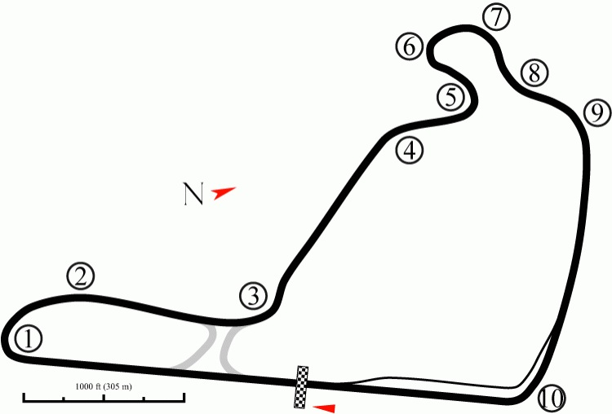

Summit Point℠ Circuit Track Map
201 Motorsports Park Cir, Summit Point, West Virginia 33647

MANDATORY SAFETY ITEMS:

Please download and complete this form before arriving at the track to help speed your check-in with the Hooked On Driving crew….. https://www.hookedondriving.com/downloads/Techical_Inspection.pdf

General:
- Car must have functioning headlights and brake lights
- Exhaust must be mounted securely and sealed
- Must have an interior and a side mirror
- Video cameras must be mounted securely (no elastic straps) mounted to a secure anchor point.

Passenger Compartment:
- Must have a secure passenger seat
- Safety restraint for driver and equivalent for passenger (includes seat belts, seat, and roll bar padding)
NOTE: Seat belts must be DOT-approved 3-point minimum. Racing style 4-, 5-, 6- point belts may be use, only if an equivalent system is available for the passenger.
- Historic cars must have a minimum of three point belts. Belts must be safely installed and well anchored.
- No window nets (windows must be fully rolled down while on track)
- No loose objects
NOTE: This includes large speakers and amplifiers. Everything must be mounted securely and will be checked. Make sure to check door pockets and seat compartment for any loose objects.
- Remove all floor mats

Roll Bars/Cages:
- Mandatory for all convertibles!
NOTE: Factory functional and “pop-up” roll bars are acceptable such as Porsche Boxster or BMW Z3 with Owner’s Manual that confirms that they are “Rollover Protection” not “Style” Bars. Honda S2000 and Dodge Viper convertibles require aftermarket roll bar.
- Roll bars should be padded and provide identical protection for driver and passenger

Trunk:
- No loose items! (The spare tire can remain, provided it is secure)

Failure to meet or to be able to correct any of the Mandatory Safety Items will eliminate your car from entering onto the track.

Under Age participants
Drivers and or passengers MUST be at LEAST 16 years old. And any driver or passenger under 18 MUST have a parent/legal Guardian present to sign a special Minor Participation Waiver as well as the standard waivers. (This does NOT apply for the Parade Laps)

TRACK EVENT INFORMATION

Shelby American is going to attend the Summit Point Motorsports Park Track Event and will bring their tractor trailer full of the latest “Shelby Specialty Cars” and drivers. A limited number of “Thrill Rides” in these vehicles will be offered throughout the day. To participate in a “Thrill Ride” you must be wearing long pants, closed shoes (no sandals or flip-flops), and preferably a long sleeved shirt. If you don’t have a helmet, one will be provided.

There will also be a car show (open to the public) for all Ford performance vehicles, with prizes and awards. If you’re not tracking your car, you can enter your Ford Performance vehicle into a car show (purchased separately for a small fee if you did not purchase the Grand or Charles Town Package).

Don’t forget to stop by the gift shop (next to the cafeteria). They have some pretty cool souvenirs! (Hint: Look for the rear window sticker that is an outline of Summit Point Motorsports Park track).

Summit Point Track “After Party”

The Hollywood Casino, WV (Evening of June 1st)
This part of the event will begin with a party at the Hollywood Casino on Thursday for all participants who purchased the Charles Town or Gold Packages (White or Gold Badges). Attire is casual, but dress up if you so desire.

The evening begins with a social in the Banquet Room. The Cash bar opens at 5:30 pm before dinner; drop off a credit card and you can have a tab.

The Buffet Dinner starts at 6:30 pm in the Banquet Room overlooking the horse track. There will be awards and presentations. Shelby American “celebrities” will be in attendance for the evening’s event as well.

Yes, we have Horses, but this time we mean REAL horses! Team Shelby will host a horse race during the evening event at 8:50 pm with a Photo-Opportunity with the winning horse and jockey. We all go down to the track 10-15 minutes before the race. The winning horse, jockey and trophy will be in placed in the winner’s circle. We all enter the circle for the Photo-Opportunity. The rest of the night, the party continues…

Don’t forget that The Inn at Charles Town provides a complimentary breakfast buffet daily for hotel guests from 6:30-10:00 am on the 1st floor of the hotel.

If you are not traveling to Carlisle, PA with us, Keep the Shiny Side Up and we’ll see you next year!

If you are traveling to Carlisle PA with the rest of us… keep reading. More information on the Poker Cruise is coming up. Pre-Poker Cruise staging begins Friday at 8:00 am and we depart promptly at 8:30 am.

Poker Cruise – June 2nd

Charles Town, WV to Carlisle, PA

This part of the event will begin at the Hollywood Casino parking lot on Friday at 8:00 am and departs promptly at 8:30 am. If you want to “group-drive” with specific friends, please stage your cars early, the earlier the better.

If your car number is not displayed either on your door or smaller decal on your windshield you will NOT be able to participate in the poker portion of the cruise, but you’ll be more than welcome to follow us and enjoy the drive.

Please stay in line. It doesn’t matter if you’re first or last because…

THIS IS NOT A RACE!

POLICE – Yes, we all know they are out there. Please obey all traffic laws on the Poker Cruise from Charles Town, WV to Carlisle. PA.

There are 4 Phases: (got enough fuel in your gas tank?)
- Cruise to Gettysburg –58.7 miles (1 h 40 min)
- Cruise to a Lunch Stop – 1 mile (5 min)
- Cruise to Carlisle, PA – 45.8 miles (1 h 5 min)
- Team Shelby Grand Entrance

Each car will be given playing cards (at random) at 4 specific stops during the “Poker Cruise”. Your first card will be given at the start of the cruise at Hollywood Casino staging area, the second in Gettysburg at the State of Pennsylvania Monument (Auto stop #12), the third during the lunch stop at the Appalachian Brewing Company (Gettysburg Battlefield) and the fourth at the Team Shelby Grand Entrance staging area into the All Ford Nationals in Carlisle, PA.

We know what you’re thinking… Where’s the fifth card? The 5th card will be handed out at the “Cars under the Stars” event (during dinner) at the Ford Expo Center if you purchased the Carlisle or Gold package. Make sure to bring all the cards you receive during the Poker Cruise. You just might be a winner!

Morning Start – Phase #1
It’s time now to begin our journey to Carlisle, PA with a Poker Cruise!

We stage our cars on Friday at Hollywood Casino parking lot by 8:00 am and we’ll depart promptly at 8:30 am. If you want to “group-drive” with specific friends, please stage your cars early, the earlier the better. Our Staging area is by the WEST GARAGE shown below.

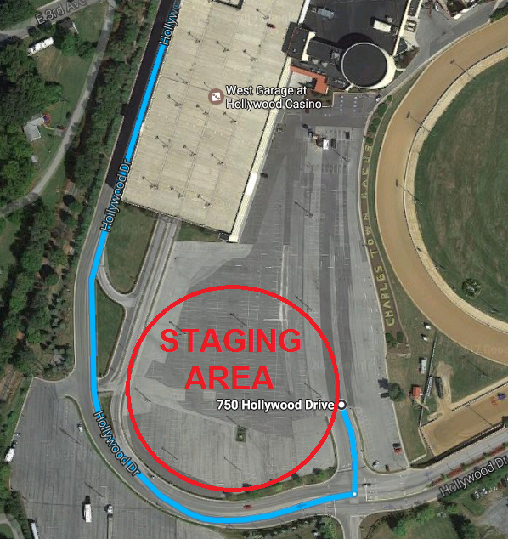

DRIVING DIRECTIONS TO GETTYSBURG AUTO STOP #12

Total Travel Estimate: 1 h 40 min (58.7 miles)

START: Exit the Hollywood Casino Parking Lot

- Turn right at the 1st cross street onto Hollywood Dr – 0.4 mi
- Turn right onto E 5th Ave – 0.5 mi
- At the traffic circle, take the 2nd exit onto Flowing Springs Rd (towards 9W)– 7.4 mi

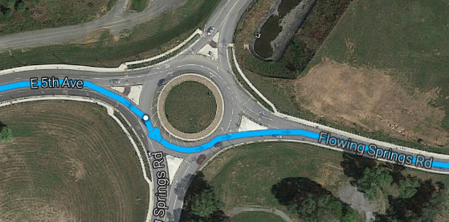

- Slight left onto WV-230 N – 2.1 mi
- Turn right onto S Princess St – 0.1 mi
- Continue straight onto N Princess St – 479 ft
- Turn left onto W German St – 0.3 mi
- Turn right onto WV-480 N/N Duke St – 0.3 mi
** Entering Maryland; WV-480 N transitions to MD-34 E
- Continue straight on MD-34 E – 9.9 mi
- Continue straight through the town of Boonsboro (no turns) – 0.6 mi
- Continue onto Boonsboro Mountain Rd – 3.1 mi
- At “T” intersection – Turn right onto US-40 E – 0.7 mi
- Turn left onto Pleasant Walk Rd (Before bottom of hill – SLOW DOWN) – 4.0 mi
- Continue straight onto Stottlemyer Rd – 5.4 mi (See map below)
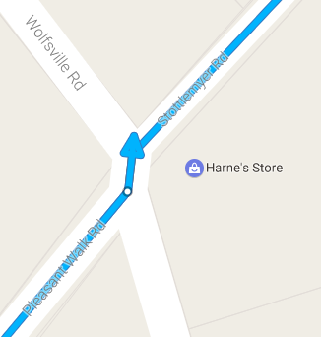
- At Stop Sign – Turn right onto Foxville Rd / MD-77 E – 5.5 mi
- Turn left to merge onto US-15 N – 10.8 mi (Welcome to Pennsylvania)
- Take the exit toward US-15 BUS/Steinwehr Ave – 0.1 mi (See map below)
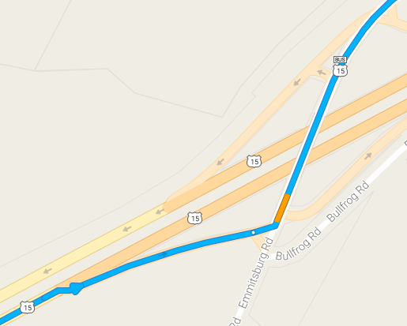
- Turn left onto US-15 BUS N (signs for Gettysburg) – 4.1 mi
- Watch for a sharp right onto S Confederate Ave – 1.5 mi (No sign – Enter Battlefield)
- Follow S Confederate Ave straight thru on Sykes Ave, Sedgwick Ave, Hancock Ave (no turns) to State of Pennsylvania Monument – 1.3 mi

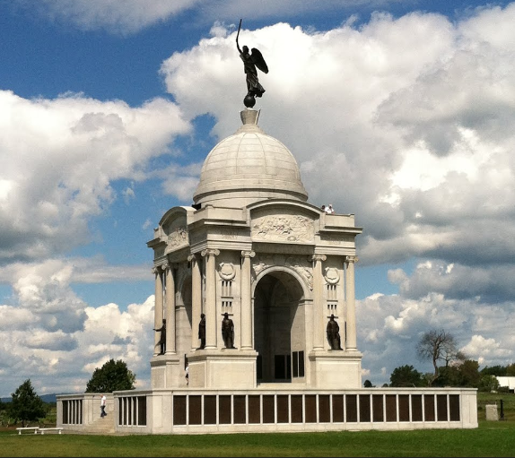
State of Pennsylvania Monument
Gettysburg Auto Tour Stop 12
Hancock Ave, Gettysburg, PA 17325

You’ll have about 30 – 45 minutes to walk around and stretch your legs and take in the sites before the Appalachian Brewing Co opens at 11:00 am (5 min away). ** We’re going to get a group photo on the stairs of the monument.

Lunch Stop – Phase #2
DIRECTIONS TO APPALACHIAN BREWING CO
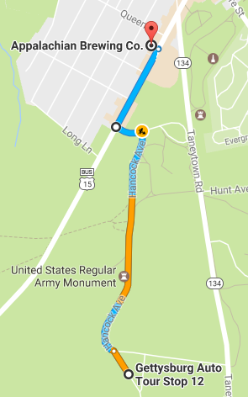
START: Gettysburg Auto Tour Stop 12

- Head northwest on Hancock Ave toward Pleasonton Ave – 394 ft

- Slight left to stay on Hancock Ave – 0.6 mi

- Turn left onto Cyclorama Dr. – 397 ft

- Turn right onto US-15 BUS N/Steinwehr Ave – 0.2 mi

- Destination will be on the left

STOP: Appalachian Brewing Co.
259 Steinwehr Ave, Gettysburg, PA 17325

Total Travel Estimate: 1 mile (5 minutes)

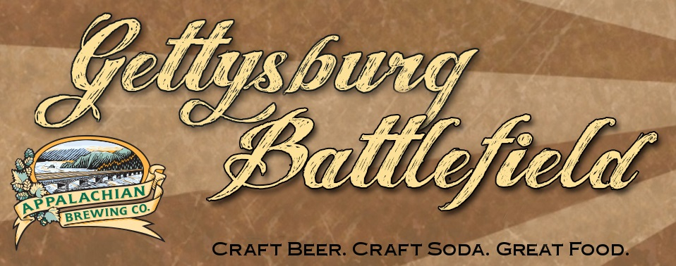
http://abcbrew.com/brewpubs/camp-hill/
259 Steinwehr Avenue, Gettysburg, PA 17325
Phone: 1-717-334-2200

Don’t forget to get your Poker Cruise card.

Appalachian Brewing Co to Carlisle, PA – Phase #3

DIRECTIONS TO CARLISLE FIRE AND RESCUE SERVICES

Total Travel Estimate: 45.8 miles (1 hour 9 minutes)

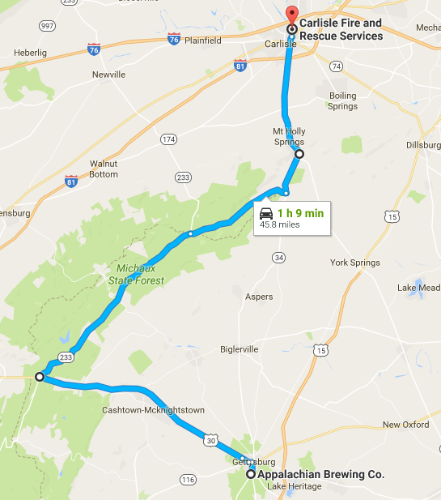

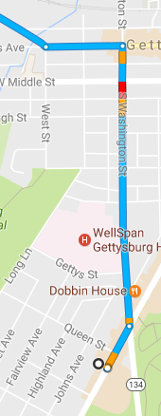
START: Appalachian Brewing Company to PA-233 N

- Turn left onto Steinwehr Ave – 0.1 mi
- Slight left onto S Washington St – 0.6 mi
- Turn left onto Chambersburg St – 0.2 mi
Continue to follow signs to US-30 W
- Turn slight right onto Buford Ave – 0.5 mi
- Continue (becomes) on US-30 W/Lincoln HWY – 13.9 mi

- Turn right onto PA-233 N toward Caledonia State Park (See mini map)

Mini Map to PA-233 N
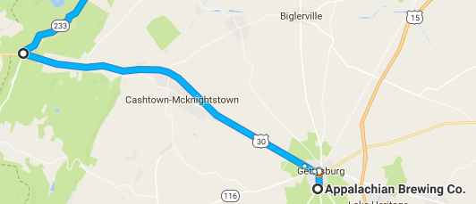

Micro Directions PA-233 N to PA-34 N
- Continue on PA-233 N – 13.3 mi
- Continue straight (no turns) onto Pine Grove Rd – 6.7 mi

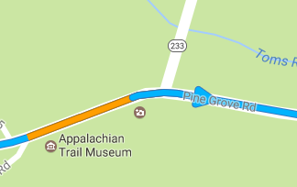

- At the STOP sign turn Left onto PA-34 N (Carlisle Road)

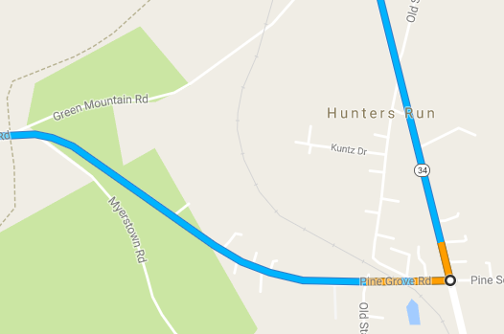
- At the STOP sign make a slight Left (S. Baltimore Ave) to continue traveling on PA-34 N – 7.4 mi

SPECIAL PRECAUTION:

Traffic on 94 N / S. Baltimore Ave do not have stop signs. This intersection is mostly a blind corner for viewing traffic approaching from the South – usually semi trucks! (See map below}

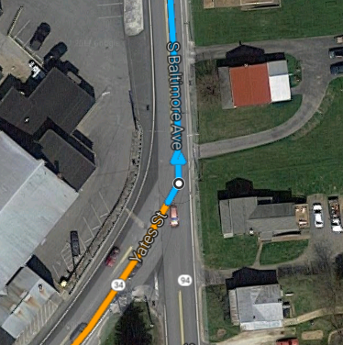

Micro Directions PA-34 N to Carlisle Fire & Rescue

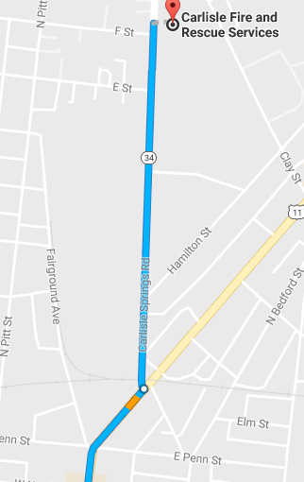
- Stay on PA-34 N (transitions to Hanover Street) – STAY IN THE RIGHT LANE AFTER OVERPASS
- Turn left onto Carlisle Springs Rd N – 0.5 mi
- Turn right (at E Street) into the parking area BEFORE the Carlisle Fire & Rescue parking lot
STOP: Destination will be on the right
(See Phase #4 Map)

Team Shelby Grand Entrance

Staging Area – Phase #4 Map

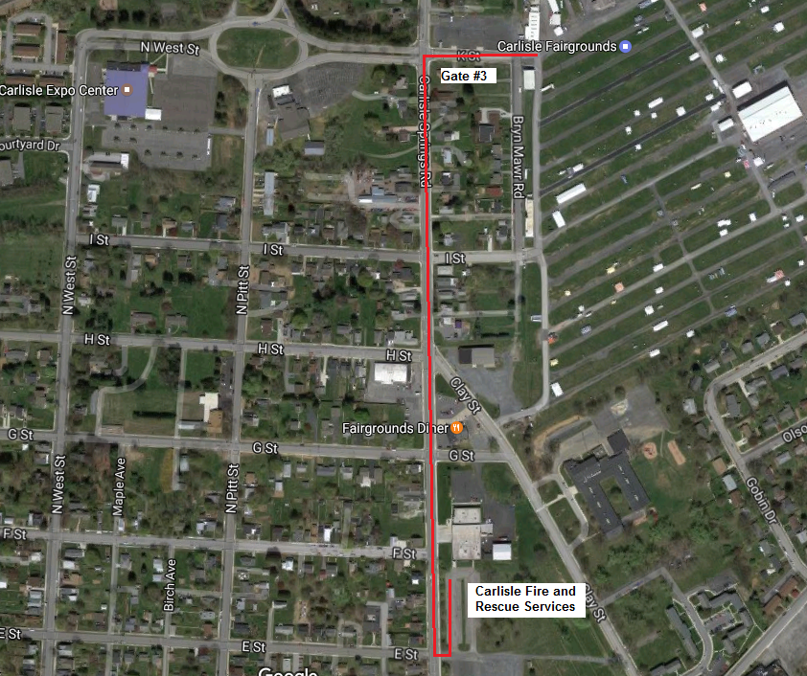
Carlisle Fire and Rescue Services
177 Carlisle Springs Rd, Carlisle, PA 17013

The map is simple and easy to follow.

Team Shelby Member stage on the left facing South (Red Line). All other (public) Ford Performance cars stage on the right facing North – to go around the U-turn and will follow our lead into the Team Shelby Grand Entrance.

This will be the same staging area for Team Shelby Lineup the Carlisle Parade.

Team Shelby Grand Entrance
into the All Ford Nationals – Friday June 2nd

Carlisle All Ford Nationals Window Sticker – Hopefully by now, you have already pre-registered with Carlisle Events and secured your Gate-N-Go Showfield entry window sticker and affixed it to your windshield. The deadline for preregistration is before May 1st, 2017. Choose the TEAM SHELBY drop down under clubs when registering. Don’t forget to pick up your Poker Card #4 if you were on the Poker Cruise.

If you don’t have your window sticker, you will have to get your window sticker at Gate 3 BEFORE the Team Shelby Grand Entrance or you will not be allowed to enter the Carlisle Showfield!

Parking: You must always park in your class designated parking area at all times, regardless of car club affiliations or events, unless special permission is granted. Depart as needed to prepare yourself for the event you’ve all been waiting for… “Cars under the Stars”.

Team Shelby at Carlisle All Ford Nationals
Jun 2-4, 2017

ENTRANCE INTO THE ALL FORD NATIONALS:

If you missed the deadline to preregister, you will have to get your window sticker at Gate 3 when you arrive. You will not be allowed to enter the Showfield without a window sticker. So, we highly recommend you pre-register before the deadline.

IMPORTANT NOTICE: This year, all auto classes will be assigned a different Class Number when the Showfield is laid out. The window stickers’ numbers may change from the original registration numbers. The new number will be on your windshield sticker and all signs at the event. You must always park in your class designated parking area at all times, regardless of car club affiliations or events, unless special permission is granted.

Carlisle Host Hotel
Want to stay with all the Team Shelby Members in Carlisle, PA? We decided on the same place as last year, and we negotiated a better rate than last year! Our host hotel is the Comfort Inn PA Turnpike – I-81 in Carlisle, PA. (The hotel is approximately 3 miles from the fairgrounds)

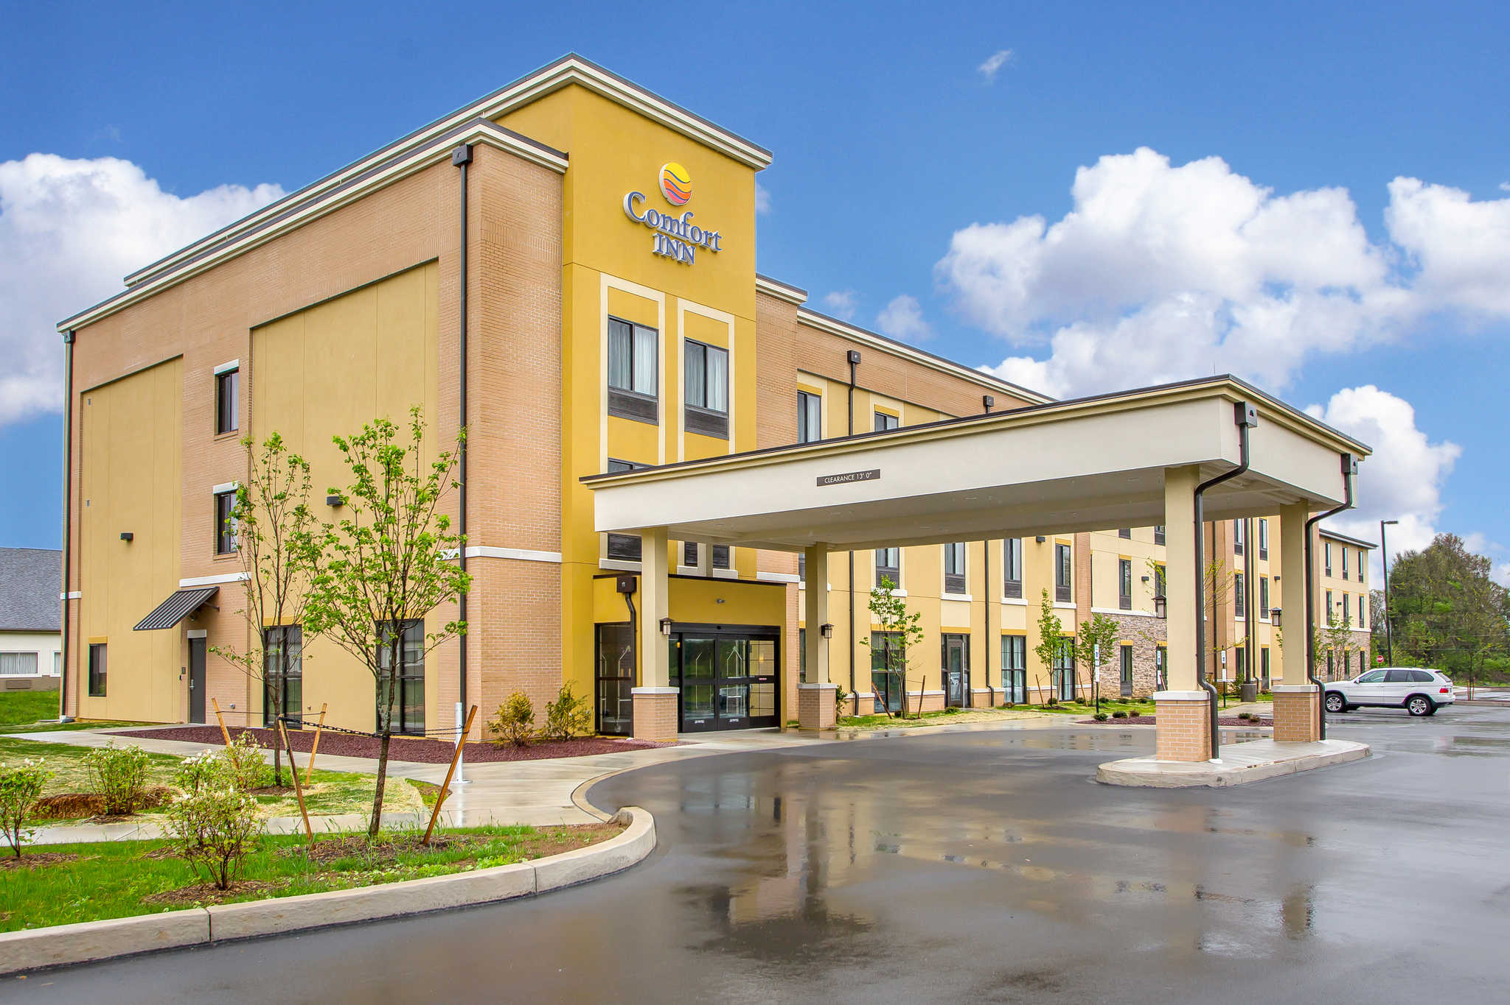
SOLD OUT
Comfort Inn PA Turnpike – I-81
77 Shady Lane, Carlisle, PA 17013
https://www.choicehotels.com/…/car…/comfort-inn-hotels/pa693
For reservations call: 1-717-706-3400
$139* per night
Check in – June 2nd, Checkout – June 4th
* To receive the $139 room rate you must say you are a member of Team Shelby to get this rate. Plenty of parking for trucks and trailers!!!

“Cars under the Stars” including the
“Show & Shine” car show – Friday June 2nd

This is the night we’ve all been waiting for…”Cars under the Stars” amongst the latest new Ford vehicles! Team Shelby brings you an unbelievable night of great cars, dinner, alcoholic beverages, guest speakers, presentations, prizes, a live bidding charity auction to benefit the Carroll Shelby Foundation and live entertainment at the Ford Expo Center.

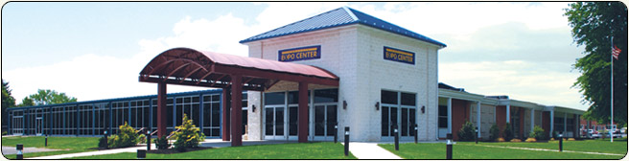
Carlisle Expo Center Lobby Entrance

This is a casual affair for all participants who purchased the Carlisle or Gold Packages (Blue or Gold Badges). Attire is casual, T-shirts and shorts are acceptable. Parking is off-street parking in the parking lot in front of the Expo Center. There will be a Beer & Wine bar available (bring your ‘green’ drink tickets) or you can BYOB. Alcohol can only be consumed by those 21 and older. Please drink responsibly!

Activities begin outside at 5:30 pm in the parking lot at the Ford Expo Center with the “Show & Shine” car show. The car show will use the "People's Choice" format where Your Vote Counts! Each entrant will receive a ballot to select their favorite choices. The cars with the most votes will receive awards with the highest rank award being “Best of Show”. Voting starts as soon as you arrive and ends at 10:00 pm. (“Show & Shine” trophies will be awarded on Saturday at 2:00 pm at the Team Shelby Hospitality Tent on the Carlisle Fairgrounds).

We start the inside evening activities with dinner at 6:30 pm – no assigned seating, sit where you like. Dinner will be a catered buffet style dinner.

Remember: We’ll hand out your 5th Poker Cruise card during dinner. So bring all the poker cards you received during the Poker Cruise to dinner. The winning hand will be presented with a Poker Cruise trophy.

The party continues with “Hanging Out with Friends and Cars”. Special guest appearances by Shelby American, Ford Motor Company/Ford Performance, as well as others, will make presentations. There will be a charity auction for the Carroll Shelby Foundation, raffles, giveaways, prizes, and “other prizes” too. Live entertainment is provided by “Tommy Tequila”.

Team Shelby at Carlisle All Ford Nationals
June 2nd and 3rd

Experience all that is Carlisle Ford Nationals, and there is a lot to experience! There will be over 3000+ cars to see. This is the largest and most thrilling all-Ford event in the world. Ford, Mercury and Lincoln fans will have a showcase of nearly 3000 vehicles to check out on the National Parts Depot Showfield.

During this event, you will enjoy great indoor displays of concepts, customs and historically-significant cars and trucks; test drives by Ford Motor Company, a burnout competition, activities for the kids, industry guests, giveaways, autocross for all skill levels and club gatherings. The excitement continues with a shopping experience you won’t soon forget as part of the enormous swap meet, car corral and the Manufacturers Midway for the best in parts buying

Team Shelby participants will enjoy live music and refreshments (redeem your “orange” drink tickets for a special Shelby branded beverage) under the Team Shelby Hospitality Tent, located inside the Carlisle Fairgrounds surrounded by the Shelby car show classes with “Shelby Girls”, live music, Cars under the Stars award winners announced.
Carlisle Saturday Night

Parade & Team Shelby Premier Event – Saturday June 3rd
This is a favorite of the Carlisle Ford Nationals. Be a part of a 400+ vehicle parade leading to downtown Carlisle (purchased separately). The streets are closed off and the parade literally parks in the middle of every street in downtown Carlisle. You must be registered for the All Ford Nationals to register for the parade. To join in the parade please sign up at Carlisle events or at Guest Services on the Showfield near the Grandstands. Don’t forget to pick up your gift bag while you’re there too! The parade lines up at the Carlisle Fire and Rescue Services on Spring Rd. at 6:00 pm and leaves at approximately 6:30 pm.

Once we arrive downtown, the town is ours for the evening! You are on your own to visit the bars and restaurants in the area for dinner, and the shops will stay open for a little shopping and you can even get an after dinner ice cream if you’d like. Live music will fill the evening hours, usually on multiple stages.

Or, if you don’t like parades….

Join us for a Shelby exclusive happy hour at the Carlisle Theater (40 W High St, Carlisle, PA), starting at 6:00 pm, as we prepare for the East Coast premiere of “The 24 Hour War”, a full length documentary directed by Adam Carolla and Nate Adams, telling the story of Ford/Shelby versus Ferrari at Le Mans in the 1960’s. This event includes a “Red Carpet” paparazzi entrance photo op, beer/wine bar (use your “yellow” drink tickets) with hors d'oeuvres, celebrity guests, and the rare opportunity to see this movie on the big screen! Team Shelby members get priority seating before the general public enters (at cost). Attire is casual, but dress up if you so desire. We recommend anything Shelby! Watch the trailer: https://chassymedia.com/trailer/

NOTE: If you do choose the Parade option over the “Red Carpet” happy hour, we have set our program such that you will still be able to participate in the parade, but will need to head directly to the theater as soon as you get parked in downtown Carlisle, in order to arrive before the doors open to the public.

Carlisle Awards & Wrap-up
We wrap things up on Sunday with the Carlisle Awards Ceremony. Come out and check out what you missed the day before, find great deals on parts and accessories, and enjoy the cars one last time before heading home.

For those wanting to participate in Sunday services, a non-denominational Christian gathering is held at 9:00 am in the main grandstand, on the Carlisle Fairgrounds.

At 1:00 pm, the Carlisle Events Award Parade will have all the show class winners line up and cruise past the main grandstands to receive their awards. Take a seat in the stands and watch as all the best cars of the weekend come to you!

Detailed Schedule Of Events

THURSDAY, JUNE 1ST
Summit Point Motorsports Park Track Event
Time: | Event: | Place:
6:00 am to 7:00 am | Breakfast 1st floor of the hotel | The Inn at Charles Town, WV
7:00 am to 5:00 pm | Gates Open to Gates Close | Summit Point Motorsports Park Track Event
7:00 am to 5:00 pm | Grand Nationals Credential Pickup
7:00 am to 8:00 am | Driver registration for track cars
8:00 am | Mandatory Meeting – ALL drivers
9:00 am to 12:00 pm | Cars on track
12:00 pm to 1:00 pm | Lunch provided at the track
1:00 pm to 5:00 pm | Cars on track
TBD | Parade laps
5:00 pm | Track closes
5:30 pm to 6:30 pm | Social in the Ball Room Bar | After Track Event Party @ Hollywood Casino in the Banquet Room
6:30 pm to 8:50 pm | Buffet Dinner in the Banquet Room
8:50 pm to 9:30 pm | Team Shelby Sponsored Horse Race
9:30 pm to 11:30pm | Social/Presentations/awards

FRIDAY JUNE 2ND
Poker Cruise: Charles Town, WV – Carlisle, PA
Time: | Event: | Place:
6:00 am to 8:00 am | Breakfast 1st floor of the hotel | The Inn at Charles Town, WV
8:00 am | Cars Line Up – Poker Cruise Card #1 | Hollywood Casino, WV
8:30 am | Cars Departs to Gettysburg
8:30 am to 10:45 am | Cruise– Poker Cruise Card #2 at stop | Cruise Route Phase #1
10:45 am to 11:00 am | Cruise to Lunch Stop | Cruise Route Phase #2
11:00 am to 12:00 pm | Lunch – Poker Cruise Card #3 at stop | Appalachian Brewing Co
12:00 pm to 2:00 pm | Poker Cruise Final Leg to Carlisle | Cruise Route Phase #3
2:00 pm | Team Shelby Grand Entrance lineup – Poker Cruise Card #4 | Phase #3 Ending Cruise Stop
3:00 pm | Team Shelby Grand Entrance departs
4:00 pm | 50th Anniversary Shelby Super Snake & Shelby Truck “Walk Arounds” | Carlisle Fairgrounds  Grandstands Main Stage
"Cars Under the Stars" Event
5:30 pm to 6:30 pm | Grand Nationals Credential Pickup | Ford Expo Center Lobby
5:30 pm | Cars arrive & Socialize | Ford Expo Center  Parking Lot
5:30 pm to 10:00 pm | “Show & Shine” car show, Show Ballots Collected
5:30 pm to 6:30 pm | Outside Social (weather permitting) | Ford Expo Center  Main Hall
6:30 pm to 10:00 pm | Dinner
 | Poker Cruise Card #5
 | Presentations/awards/entertainment
 | Carroll Shelby Foundation Auction

SATURDAY JUNE 3RD
Time: | Event: | Place:
7:00 am | Carlisle Fairgrounds Gates Open | Carlisle Fairgrounds
8:00 am to 12:00 pm | “Social” and Credential Pickup | Team Shelby Hospitality Tent
11:00 am | 50th Anniversary Shelby Super Snake & Shelby Truck “Walk Arounds” | Carlisle Fairgrounds  Grandstands Main Stage
Noon | Team Shelby Luncheon followed by “Cars Under the Stars” award presentation | Team Shelby Hospitality Tent
2:00 pm | Gary Patterson - Vehicle presentation at Shelby tractor trailer | Shelby American Display  Manufacturers Midway
4:00 pm | Ms. Carlisle Contest – Come out and cheer on our Shelby Girls!!! | Carlisle Fairgrounds  Grandstands Main Stage
If attending “Red Carpet” Event at The Carlisle Theater….
5:30 pm | Head Downtown (on your own) to park and arrive on time for the “Red Carpet” Event at The Carlisle Theater | Public Parking in Theater Area  (see map below)
6:00 pm to 7:00 pm | Team Shelby Exclusive “Red Carpet” Happy Hour | The Carlisle Theater  40 W High St, Carlisle, PA
7:15 pm to 9:00 pm | East Coast Premier Screening of “The 24 Hour War” | The Carlisle Theater  40 W High St, Carlisle, PA
If participating in Carlisle Downtown Parade….
6:00 pm | Line Up for Carlisle Downtown Parade [pre-registration required] | Carlisle Fire & Rescue on Spring Rd. To Downtown
6:30 pm | Depart for Carlisle Downtown Parade & Street Party
6:45 pm | Arrive/park in Downtown Carlisle Town Center, and proceed directly to The Carlisle Theater | The Carlisle Theater  40 W High St, Carlisle, PA
7:15 pm to 9:00 pm | East Coast Premier Screening of “The 24 Hour War” | The Carlisle Theater  40 W High St, Carlisle, PA

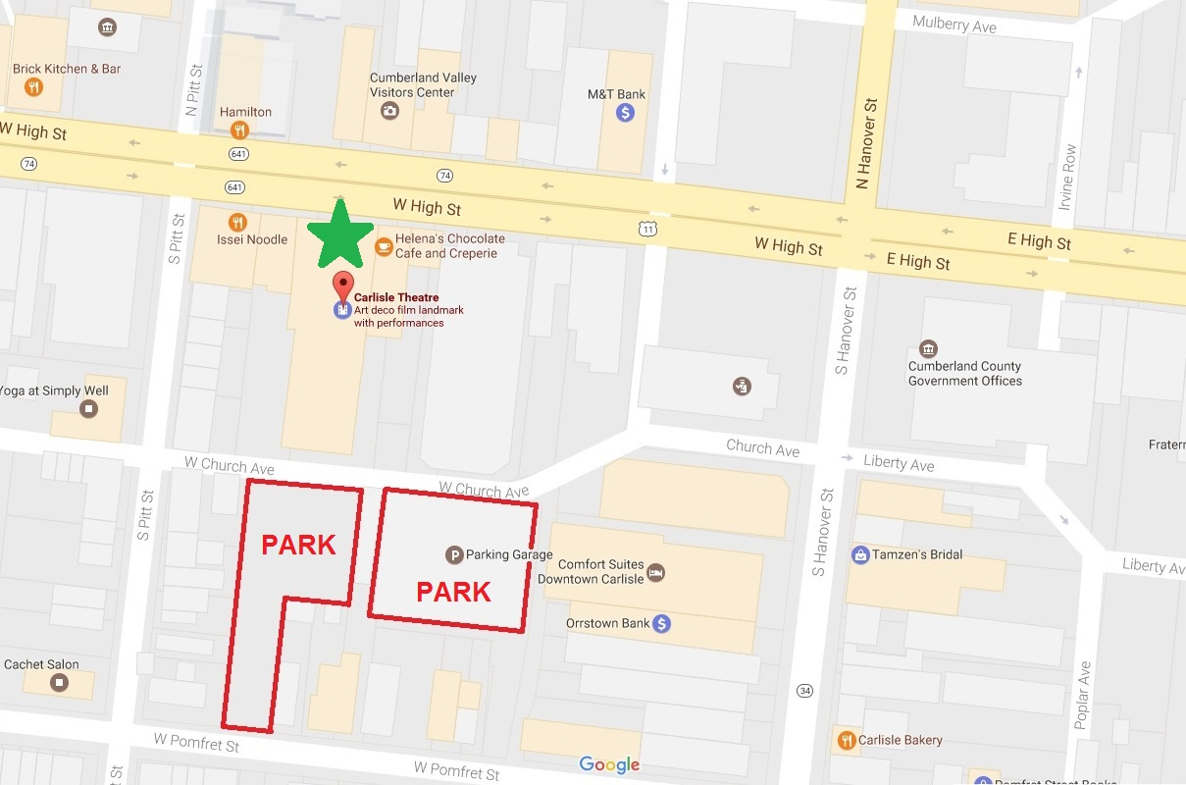
Hollywood Casino to Summit Point Motorsports Park

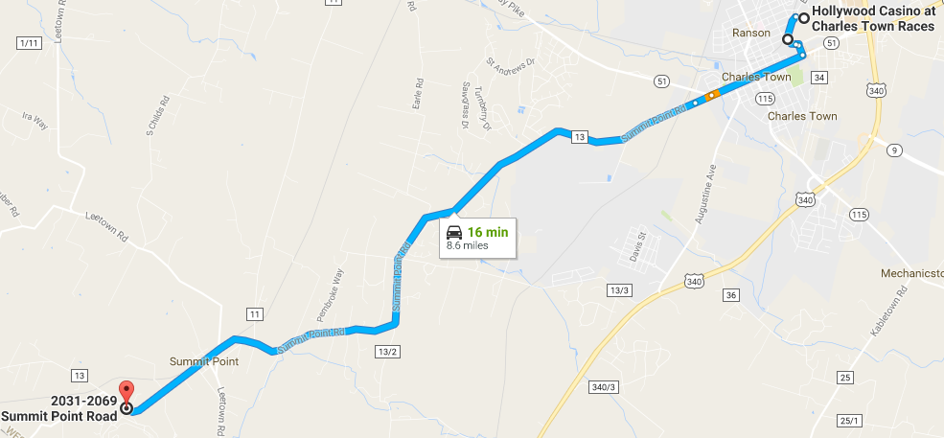
Total Travel Estimate: 8.6 miles (16 minutes)

- Head southwest on Hollywood Dr – 0.3 mi
- Turn right toward Vine St – 203 ft
- Continue onto Vine St – 0.1 mi
- Turn right onto E Washington St – 0.9 mi
- Continue straight onto W Washington St – 0.2 mi
- Continue onto Summit Point Rd – 7.0 mi
- Turn left into the Summit Point Motorsports Park
- Stop at the gate and check into the Motorsports Park
- Turn left on Summit Point Circuit Rd
- Follow the road to the Paddock area – End

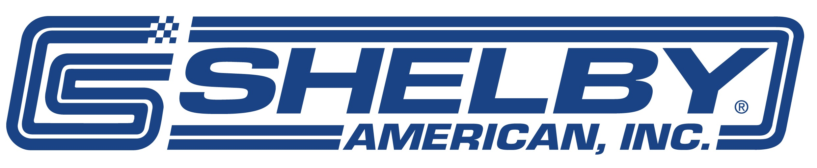

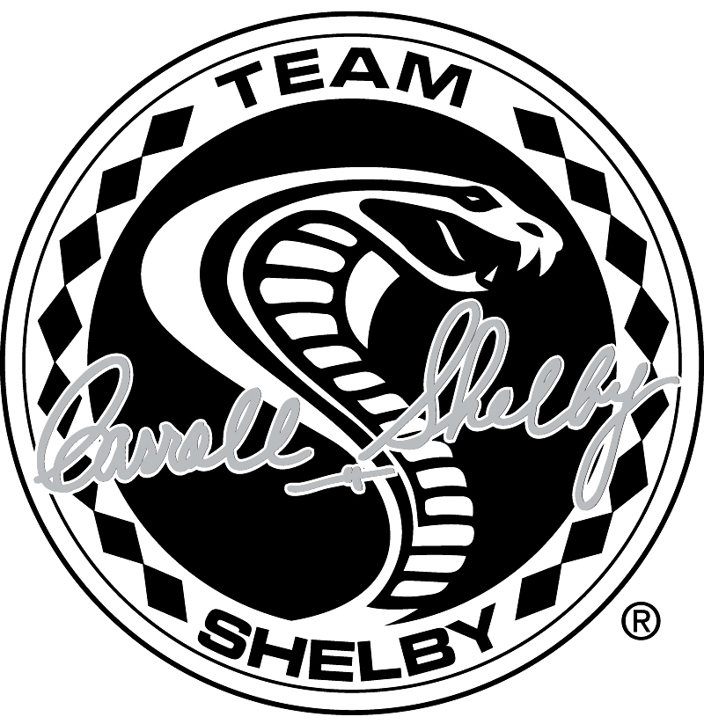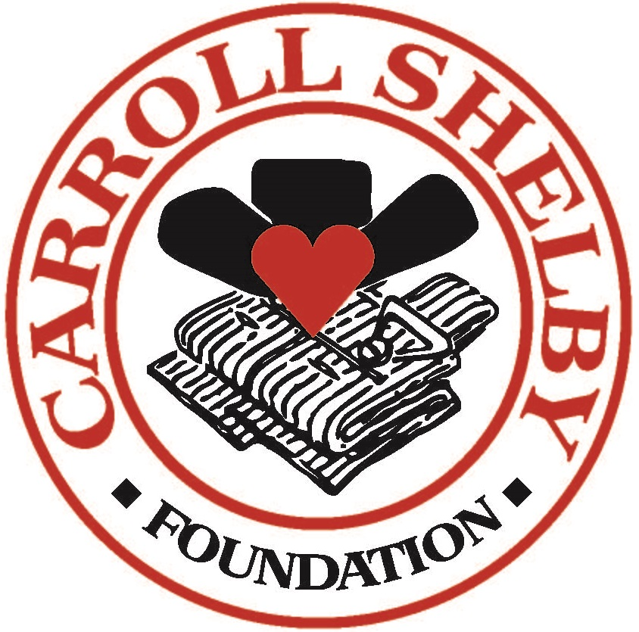

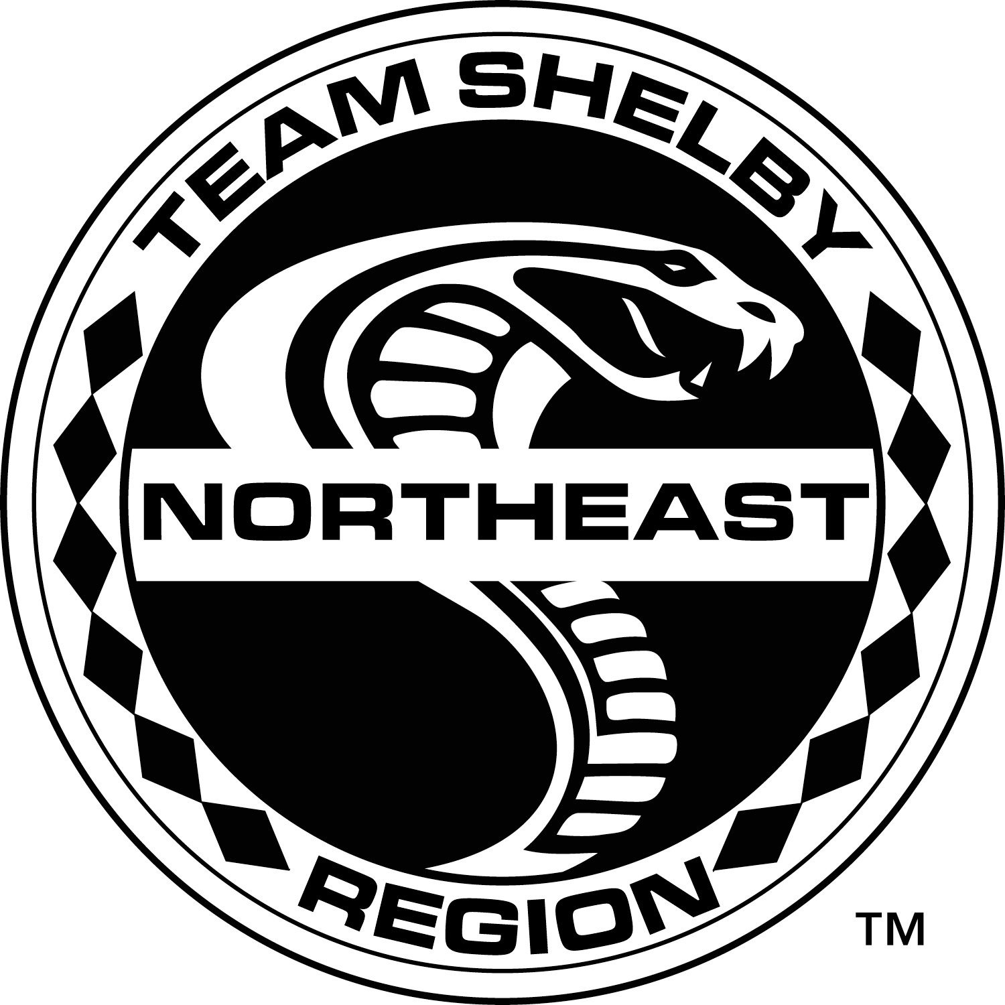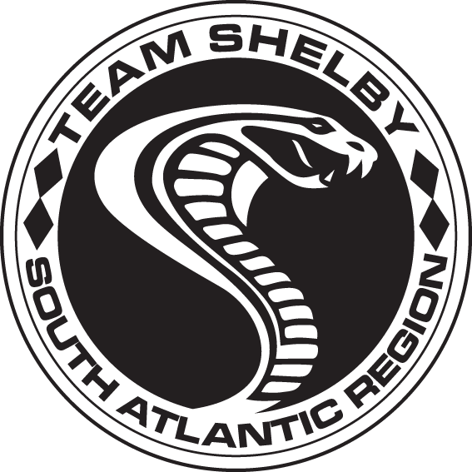

Team Shelby would like to thank all our Sponsors for their generosity and support of this event…
It would not be possible without each one of you!

GOLD SPONSOR

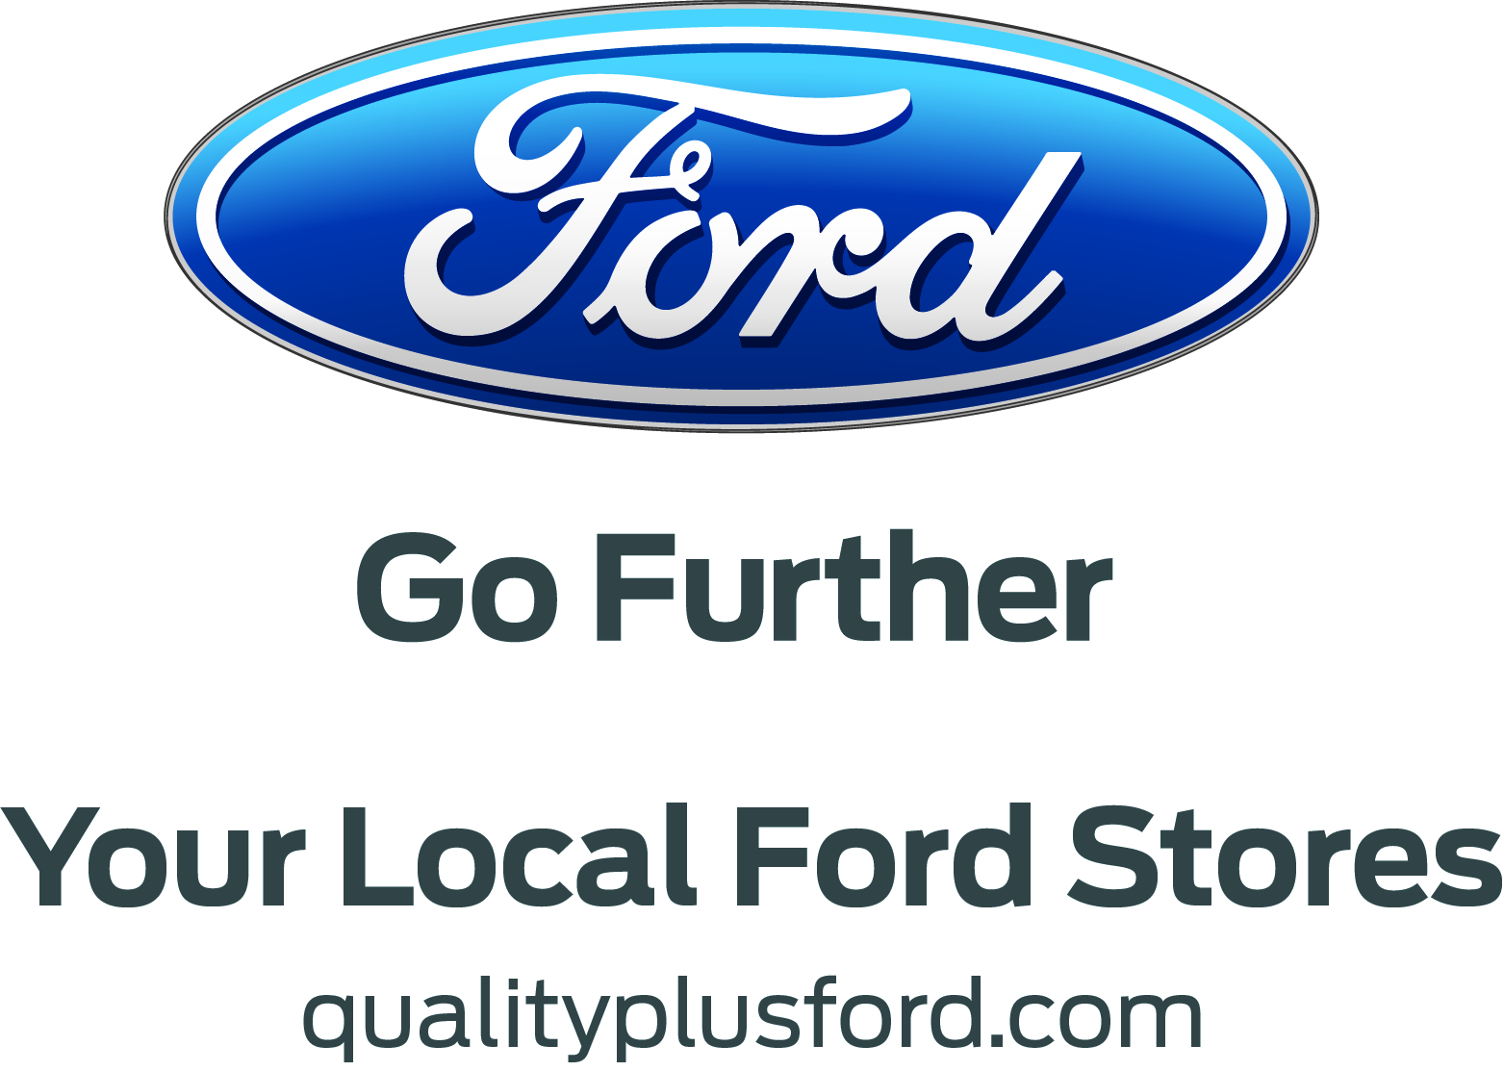

SILVER SPONSOR

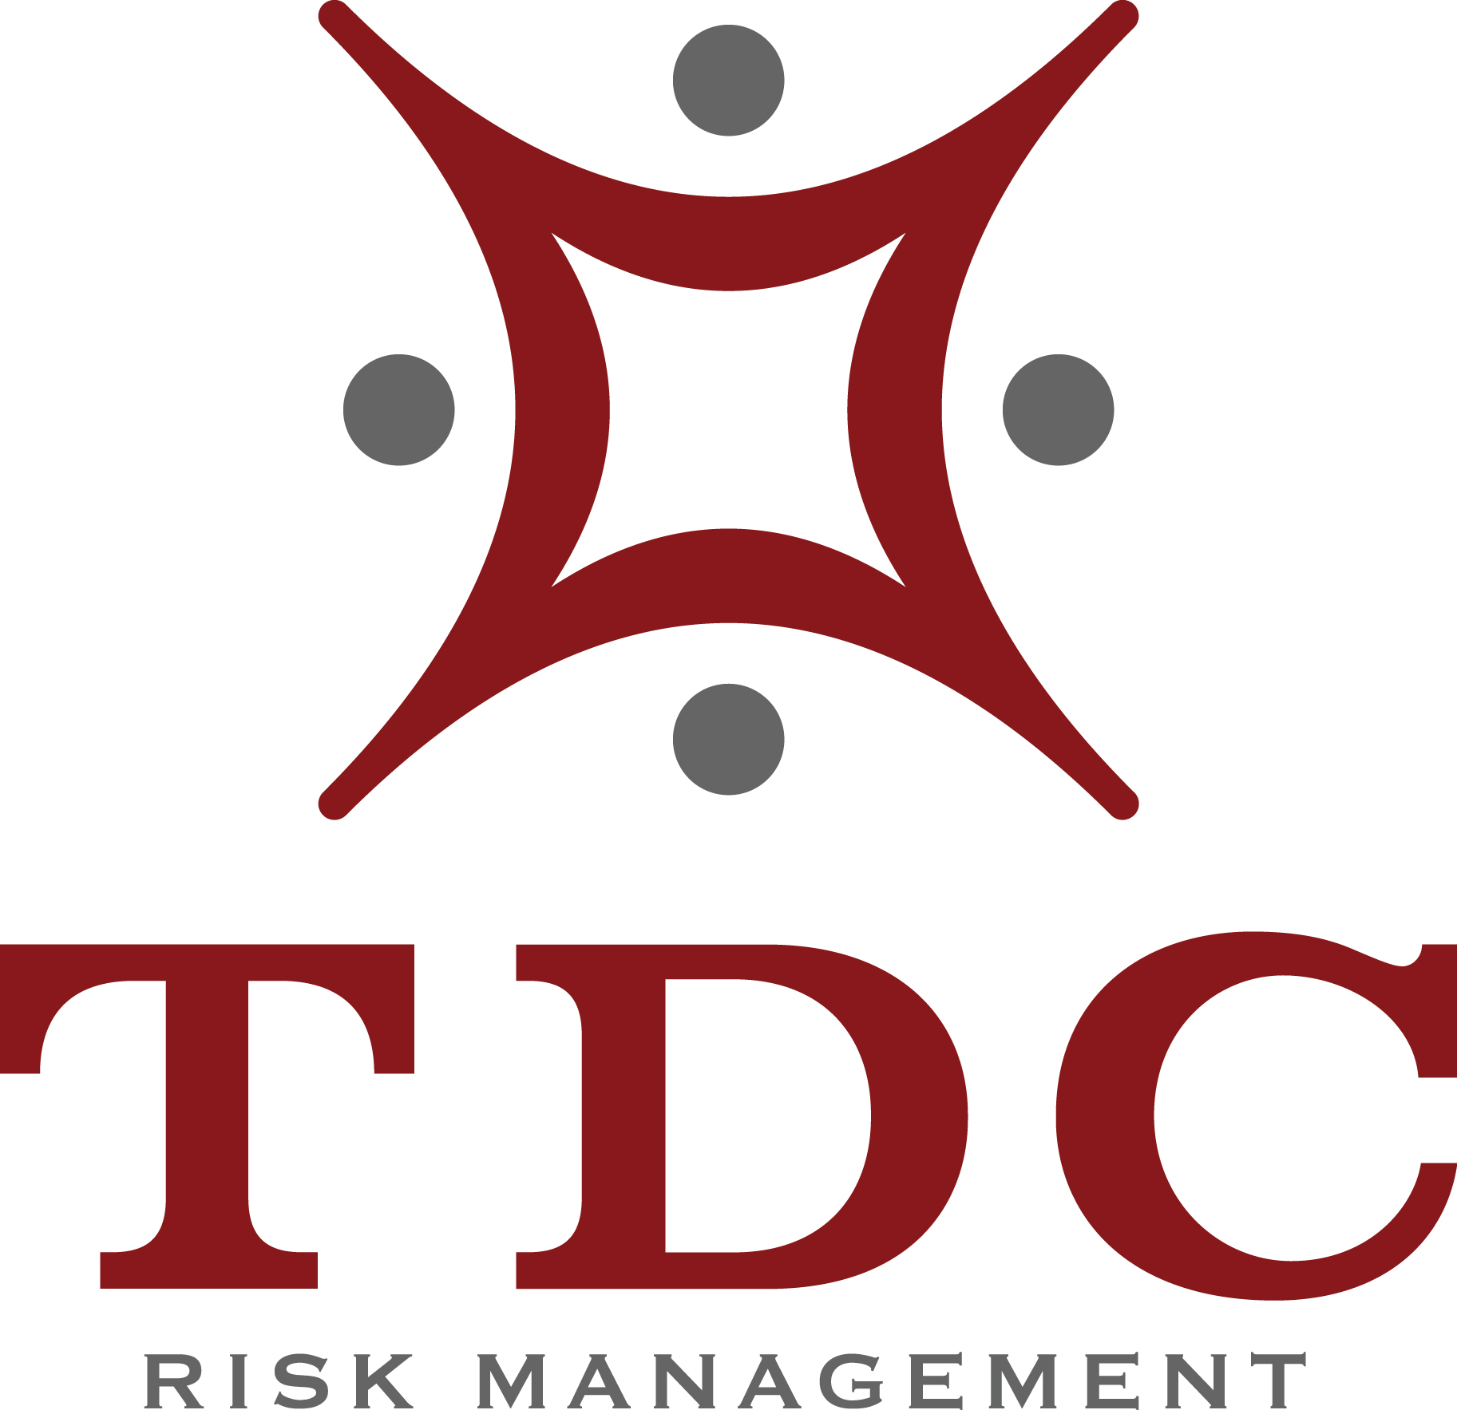

BRONZE SPONSORS
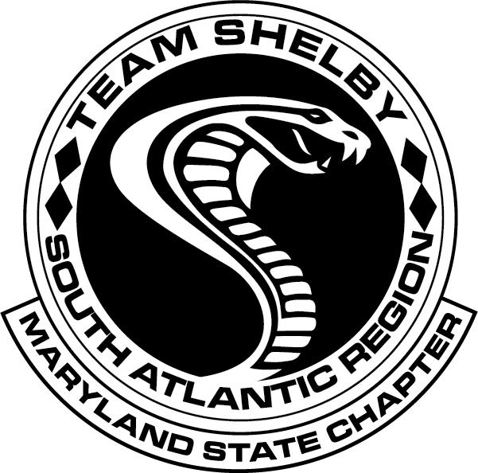
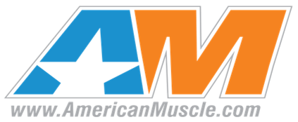
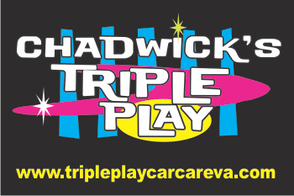

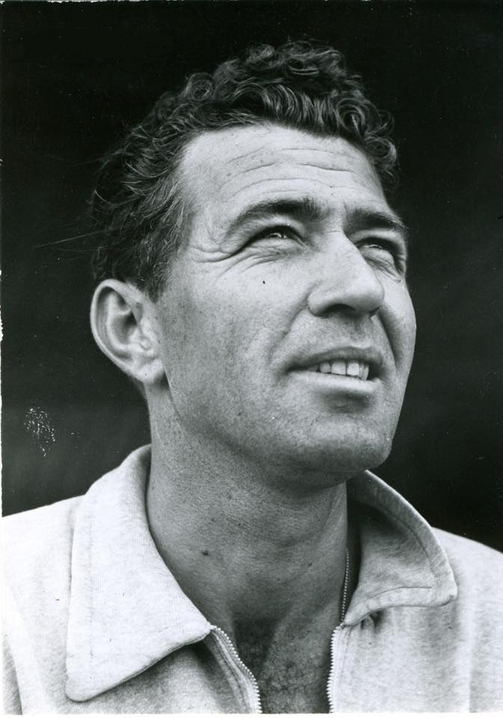
Carroll Shelby
January 11, 1923 – May 10, 2012

